Pseudo-classes in CSS

=================

A pseudo-class is used to define a special state of an element.

For example, it can be used to:

* Style an element when a user mouses over it
* Style visited and unvisited links differently
* Style an element when it gets focus

## Anchor Pseudo-classes

# There are 4 pseudo classes for <a> anchor tag

1. a:link
2. a:visited
3. a:hover
4. a:active

# <head>

# <style>

# a:link

# {

# text-decoration:none;

# color:red;

# }

# a:hover

# {

# color:green;

# border-top-style:solid;

# border-top-color:blue;

# border-top-width:3px;

# background-color:yellow;

# }

# a:active

# {

# color:orange;

# }

# a:visited

# {

# color:teal;

# }

# </style>

# </head>

# <body>

# <a href="a.html">Home</a>

# <a href="b.html">About</a>

# <a href="c.html">Contact</a>

# <a href="d.html">Login</a>

# </body>

# **<div> tag:- it is a tag of HTML. It divide page in partition with the help of css.**

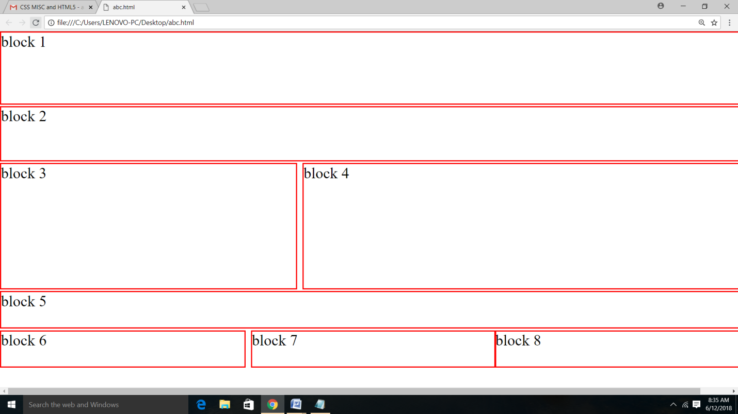

Left

Top

Height

Width

Overflow

Position

Code

<head>

<style>

div.a

{

position:absolute;

left:0%;

top:0%;

height:20%;

width:100%;

border:1px solid red;

}

div.b

{

position:absolute;

left:0%;

top:21%;

height:15%;

width:100%;

border:1px solid red;

}

div.c

{

position:absolute;

left:0%;

top:37%;

height:35%;

width:40%;

border:1px solid red;

}

div.d

{

position:absolute;

left:41%;

top:37%;

height:35%;

width:63%;

border:1px solid red;

}

div.e

{

position:absolute;

left:0%;

top:73%;

height:10%;

width:100%;

border:1px solid red;

overflow:auto;

}

div.f

{

position:absolute;

left:0%;

top:84%;

height:10%;

width:33%;

border:1px solid red;

}

div.g

{

position:absolute;

left:34%;

top:84%;

height:10%;

width:33%;

border:1px solid red;

}

div.h

{

position:absolute;

left:67%;

top:84%;

height:10%;

width:33%;

border:1px solid red;

}

</style>

</head>

<body>

<div class="a">

block 1

</div>

<div class="b">

block 2

</div>

<div class="c">

block 3

</div>

<div class="d">

block 4

</div>

<div class="e">

block 5

</div>

<div class="f">

block 6

</div>

<div class="g">

block 7

</div>

<div class="h">

block 8

</div>

</body>

CSS in Forms

<!DOCTYPE html>

<html>

<head>

<style>

input

{

color:red;

background-color:teal;

}

</style>

</head>

<body>

<form>

First Name

<input type="text" id="fname" name="fname">

Last Name

<input type="text" id="lname" name="lname">

<input type="submit">

</form>

</body>

</html>

Example 2

<!DOCTYPE html>

<html>

<head>

<style>

input[type=text]

{

color:red;

background-color:teal;

}

input[type=submit]

{

color:white;

background-color:black;

}

</style>

</head>

<body>

<form>

First Name

<input type="text" id="fname" name="fname">

Last Name

<input type="text" id="lname" name="lname">

<input type="submit">

</form>

</body>

</html>

Overflow Proprty in cSS

Value :- hidden, scroll,auto.

Example 1 of <div >tag With css To create A Block

<!DOCTYPE html>

<html>

<head>

<style>

div.a {

background-color: lightgrey;

width:300px;

border:25px solid green;

padding: 25px;

margin: 25px;

height:100px;

overflow:hidden;

}

</style>

</head>

<body>

<div class="a">This text is the actual content of the box. We have added a 25px padding, 25px margin and a 25px green border. Utenim ad minim veniam, quisnostrud exercitation ullamcolaboris nisi utaliquip ex eacommodoconsequat. Duisauteirure dolor in reprehenderit in voluptatev elitessecill umdoloreeu fugiatnullapariatur. Excepteursintoccaecatcupidatat non proident, sunt in culpa qui officiadeseruntmollitanim id estlaborum.</div>

</body>

The CSS Box Model

All HTML elements can be considered as boxes. In CSS, the term "box model" is used when talking about design and layout.

The CSS box model is essentially a box that wraps around every HTML element. It consists of: margins, borders, padding, and the actual content. The image below illustrates the box model:

Explanation of the different parts:

* **Content** - The content of the box, where text and images appear
* **Padding** - Clears an area around the content. The padding is transparent
* **Border** - A border that goes around the padding and content
* **Margin** - Clears an area outside the border. The margin is transparent

Acutal height=height+padding+border

Actual Width=width+padding+border

Example

<!DOCTYPE html>

<html>

<head>

<style>

div.a {

background-color: lightgrey;

width:200px;

border:2px solid green;

height:100px;

overflow:scroll;

padding:20px;

}

</style>

</head>

<body>

<div class="a">This text is the actual content of the box. We have added a 25px padding, 25px margin and a 25px green border. Utenim ad minim .</div>

</body>

In above example height is 144px

And width is 244px

CSS3 provide box-sizing.

Example

<!DOCTYPE html>

<html>

<head>

<style>

div.a {

background-color: lightgrey;

width:200px;

border:2px solid green;

height:100px;

overflow:scroll;

padding:20px;

box-sizing:border-box;

}

</style>

</head>

<body>

<div class="a">This text is the actual content of the box. We have added a 25px padding, 25px margin and a 25px green border. Utenim ad minim .</div>

</body>

In above example height of <div> 100px and width is 200px;

============================

<span>tag:-

It is a tag of HTML . it is used to provide look and feel to particular word or line.

<head>

<style>

#k

{

color:red;

}

</style>

</head>

<body>

<h1>Splended <span id="k">Learning</span></h1>

</body>

**CSS pseudo-elements**

CSS pseudo-elements are used to add special effects to some selectors. You do not need to use JavaScript or any other script to use those effects. A simple syntax of pseudo-element is as follows −

selector:pseudo-element {property: value}

or

selector::pseudo-element {property: value}

The most commonly used pseudo-elements are as follows −

|  |  |
| --- | --- |
| **Value** | **Description** |
| :first-line | Use this element to add special styles to the first line of the text in a selector. |
| :first-letter | Use this element to add special style to the first letter of the text in a selector. |
| :before | Use this element to insert some content before an element. |
| :after | Use this element to insert some content after an element. |

<html>

<head>

<style>

p.a::first-letter

{

color:red;

}

p.b::first-line

{

color:red;

}

</style>

</head>

<body>

<p class="a">

This is a para . This is a para . This is a para . This is a para . This is a para . This is a para . This is a para . This is a para . This is a para . This is a para . This is a para . This is a para . This is a para . This is a para . This is a para . This is a para . This is a para . This is a para . This is a para . This is a para . This is a para . This is a para . This is a para . This is a para . This is a para . This is a para . This is a para . This is a para . This is a para . This is a para .

</p>

<p class="b">

This is a para . This is a para . This is a para . This is a para . This is a para . This is a para . This is a para . This is a para . This is a para . This is a para . This is a para . This is a para . This is a para . This is a para . This is a para .

</p>

</body>

</html>

Example

<html>

<head>

<style>

p:before

{

content: url(a.jpg)

}

</style>

</head>

<body>

<p>

Result of BTECH

</p>

<p>

Result of BCA

</p>

<p>

Result of MBA

</p>

<p>

Result of BBA

</p>

</body>

</html>

Example

<html>

<head>

<style>

p:after

{

content: url(a.jpg)

}

</style>

</head>

<body>

<p>

Result of BTECH

</p>

<p>

Result of BCA

</p>

<p>

Result of MBA

</p>

<p>

Result of BBA

</p>

</body>

</html>